**National Circumstances:**

Variety of habitats.

Climate: Semi-arid to hyper-arid climate = very low rainfall (avg 150 mm)

Temperature: 50oC ranges from 27C to 43C in summer

8C to 20C in winters

Population 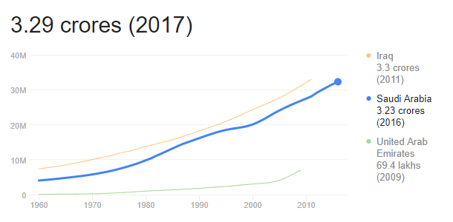

In 2010 census, the population of the Kingdom was 27.2 million, however, the population was

Estimated to be 29.9 million in 2013 and 31.02 million in 2015.

National Economy and National Development Priorities:

* Raising Standard of living
  + Average 5.26 % of annual per capita income growth from 1990-2013
  + 11th in countries with fastest progress in human development
  + 57 in global human development index
* Diversification of Economic Base
  + Diversification of economic base has been principal objective of economic and social development since the start.
  + Enhancing the role of non-oil sector in national economy – developing and export is one of the main development challenge – ninth and tenth Development plan
* Enhance Non-oil Revenues
* Balanced Regional Development
  + Developing infrastructure, public services and other necessary public facilities, along with a drive to build a production base.
* Move to Knowledge based economy
* Enhancing Competitiveness
  + Kingdom ranked 26th among 189 countries with respect to ease of doing business (2014) and the Global Competitiveness Report (2013-2014) ranked Saudi Arabia 20th among 148 countries.
* Development and Productive Employment of Human Resources
  + Labour demand surpassed Saudi labour supply in many professions
  + Education and training to reduce structural unemployment among Saudis.
* Sustainably of Natural Resources
  + Scarcity of water resources constitute vital issue
    - Largest share of water consumed for agricultural, municipal and industrial purposes comes from non-renewable resources.
  + Conservation of agricultural land and protection against degradation or desertification is a major challenge facing sustainability development.

Contribution to Adaptation

1. Adaptation with mitigation co-benefits
   1. Water and waste water management:
      1. Encourage reduction, recycle and reuse of water and wastewater in municipal.
   2. Urban Planning
   3. Marine Protection
   4. Reduced desertification
   5. Marine protection
      1. Reduce coastal erosion, increase the sinks for blue carbon, maintained related ecosystem.
      2. Support planting mangrove seedling along its coast.
   6. Reduce desertification: